# Database table structure

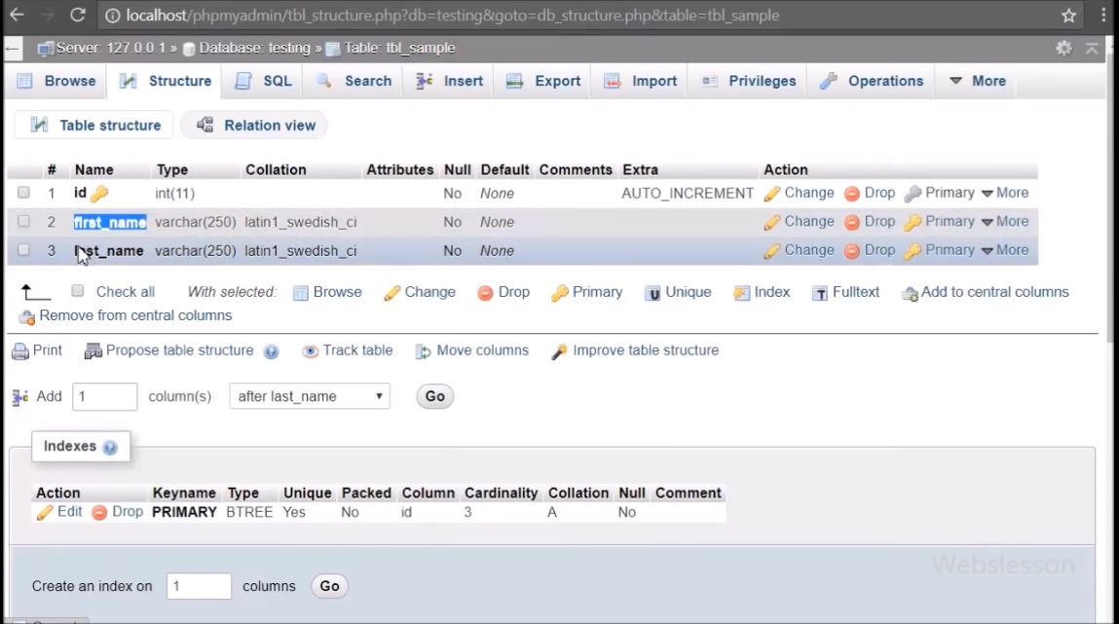

# File Structure

Api/

Api.php – one api class with database connection, functions for performed CRUD operation

Test.php - handling api request

Work/

Action.php -

Fetch.php -

Index.php -

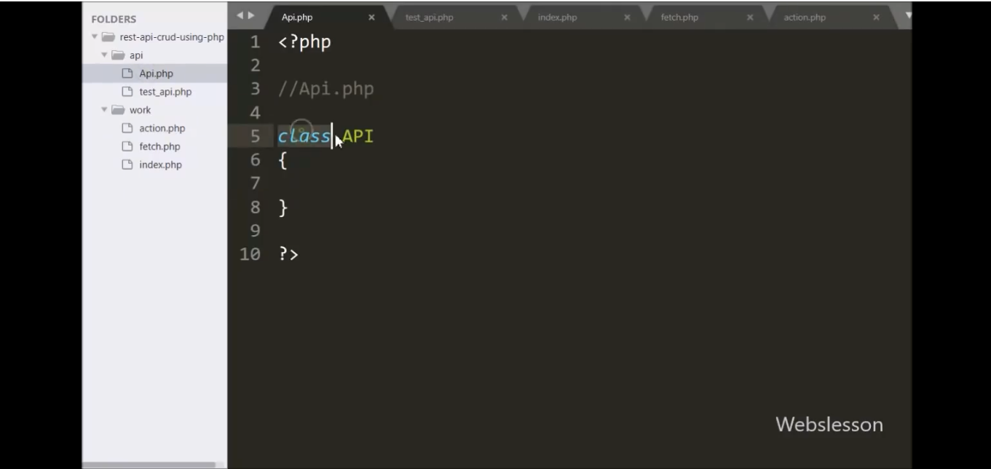

Declaring a private variable connect and making new function database connection in order to connect with database.

